Practical No 23

VIII. Resources required (Additional)
→ If any web resources required.

Resources used (Additional)
https://www.tutorialspoint.com/vb.net/vb.net

Program Code
  - 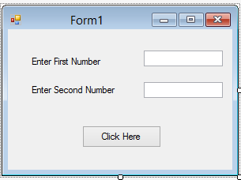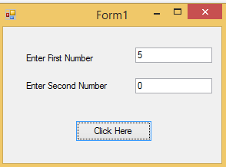Write any program using Exception handling.

Public Class Form1

Private Sub Button1_Click(sender As Object, e As EventArgs) Handles Button1.Click Dim num1, num2, div As Integer
num1 = Val(TextBox1.Text) num2 = Val(TextBox2.Text)
Try
div = num1 / num2 MsgBox("Division is" & div)
Catch ex As OverflowException Console.WriteLine("Division of {0} by zero", num1)

End Try End Sub
End Class

Output:

A first chance exception of type 'System.OverflowException' occurred in WindowsApplication8.exe
Division of 5 by zero

Practical related Questions
  - Write output of following Code.
Module Module1 Sub Main()
Try
Throw New Exception("Mega-error") Catch ex As Exception
Console.WriteLine(ex.Message)

End Try Console.ReadLine()
End Sub End Module

Output:
Mega-error

Write output of following Code.
Module Module1 Sub Main()
Try
'Try to divide by zero.
Dim value As Integer = 1 / Integer.Parse("0") 'This statement is sadly not reached.
Console.WriteLine("Hi")
Catch ex As Exception 'Display the Message.
Console.WriteLine(ex.Message)

End Try Console.ReadLine()
End Sub

End Module

Output:
Arithmetic operation resulted in an overflow.

ercise
  - Write a program for student registration using exception handling.

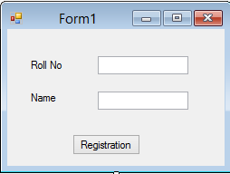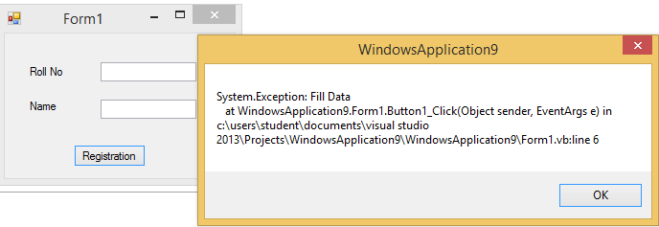

Public Class Form1

Private Sub Button1_Click(sender As Object, e As EventArgs) Handles Button1.Click Try
If TextBox1.Text = "" Or TextBox2.Text = "" Then Throw (New Exception("Fill Data"))
Else
MsgBox(TextBox1.Text & TextBox2.Text) End If
Catch ex As Exception MsgBox(ex.ToString)
Finally
MsgBox("Thank You") End Try
End Sub End Class

OUTPUT:

